**Confidence Interval**

**Problem Statement:** In an election with only two parties A and B, Survey X and Y arrived at the same vote share for Party A.

However, X sampled 300 voters and Y sampled 1200 voters.

Which of the following is TRUE?

a. The width of the confidence interval of X’s estimate is two times that of Y’s estimate.

b. The width of the confidence interval of Y’s estimate is two times that of X’s estimate.

c. The width of the confidence interval of X’s estimate is four times that of Y’s estimate.

d. The width of the confidence interval of Y’s estimate is four times that of X’s estimate.

e. Cannot be found.

**Solution:**

It is given that the vote share is equal.

Half interval width:

$$E=Z_{α/2}\sqrt{\frac{\hat{p}\left(1-\hat{p}\right)}{n}}$$

Confidence interval width:

$$2E={2Z}_{α/2}\sqrt{\frac{\hat{p}\left(1-\hat{p}\right)}{n}}$$

Calculate the confidence interval width for surveys X and Y respectively and take their ratio:

$$W_{X}=2E_{X}=2Z_{α/2}\sqrt{\frac{\hat{p}\left(1-\hat{p}\right)}{n_{X}}}$$

$$W_{Y}=2E_{Y}=2Z_{α/2}\sqrt{\frac{\hat{p}\left(1-\hat{p}\right)}{n_{Y}}}$$

$$\frac{W_{X}}{W_{Y}}=\sqrt{\frac{n_{Y}}{n_{X}}}=\sqrt{\frac{1200}{300}}=\sqrt{4}=2$$

$$W_{X}=2W_{Y}$$

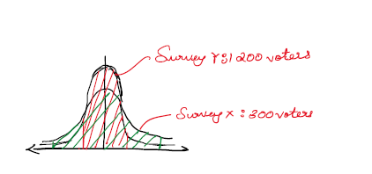

**Hypothesis Testing**

**Problem Statement:** A passport office claims that the passport applications are processed within 30 days of submitting the application form and all necessary documents.

Table shows the processing time of 40 passport applicants. The population standard deviation of the processing time is 12.5 days. Conduct a hypothesis test at significance level ɑ=0.05 to verify the claim made by the passport office.

**Table:** Passport Processing Time

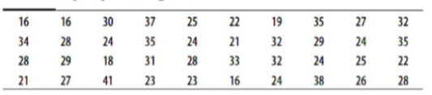

**Solution:**

**Steps:**

1. Formulating Hypothesis
2. Define test statistic
3. Calculate the p-value
4. Compare against a threshold value

**Define the hypotheses:**

$Null Hypothesis \left(H_{0}\right): μ=30 days$

$Alternative Hypothesis \left(H_{1}\right): μ<30 days$

Sample size = 40

Population standard deviation(𝝈) = 12.5 days

Significance level ɑ = 0.05

The z-test can be used for a population mean when the population standard deviation is given.

p-value: probability of observation under the null hypothesis.

Observed sample mean from the table = 27.05 days

Standard deviation of sampling distribution

$$\frac{σ}{\sqrt{n}}=\frac{12.5}{\sqrt{40}}=1.9764$$

$$Z-statistic=\frac{\overline{X}-μ}{\frac{σ}{\sqrt{n}}}=\frac{27.05-30}{1.9764}=-1.4926$$

Population standard deviation is given hence normal distribution can be used to find p.

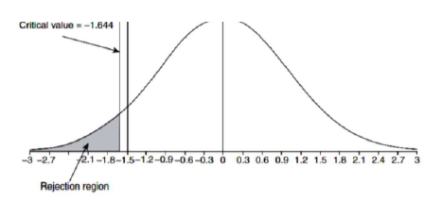

The critical value of left-tailed test for ɑ = 0.05 is **-1.644**.

Here, the critical value is less than **Z-statistic (-1.4926)** value.

$$p-value=0.0677$$

Hence, we fail to reject the null hypothesis.